**Wi-Fi Training Program**

**Assignment Solutions – Module 1**

**1. In which OSI layer does the Wi-Fi standard/protocol fit?**

Wi-Fi operates at the **Data Link Layer (Layer 2)** and the **Physical Layer (Layer 1)** of the OSI model.

* **Physical Layer (Layer 1):** Handles transmission of raw bits over the wireless medium.
* **Data Link Layer (Layer 2):** Divided into two sublayers:
  + **Logical Link Control (LLC):** Manages flow control and error checking.
  + **Media Access Control (MAC):** Defines addressing and access control (collision avoidance).

**2.**

**(I) Windows Laptop:**

Settings > Network & Internet > Wi-Fi > Wi-Fi_Name

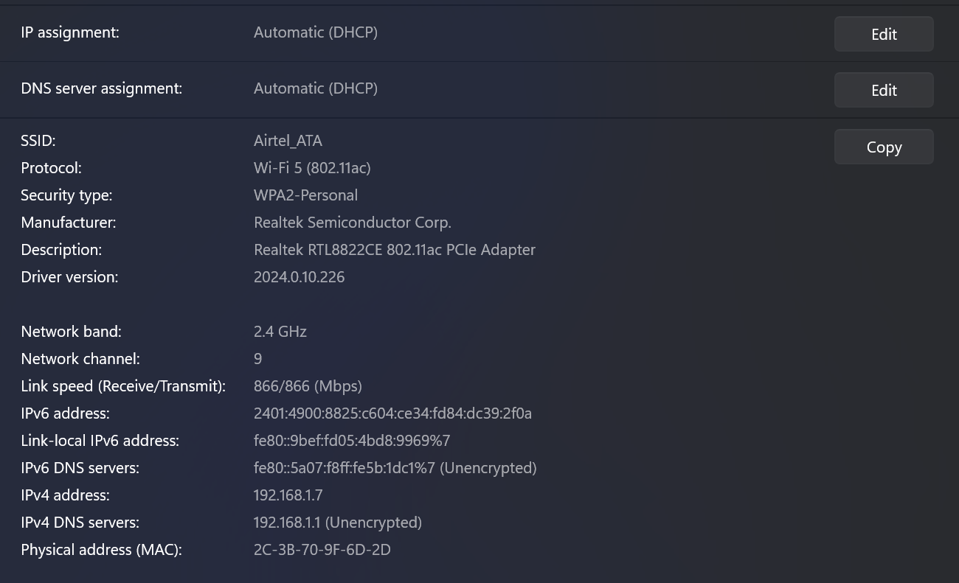

Wi-Fi Generation: Wi-Fi 5 (802.11ac)

**(II) Android Phone:**

Settings > About Phone > Software Information

Enable Developer Options

Enable Wi-Fi Verbose Logging

Go to connected Wi-Fi Settings

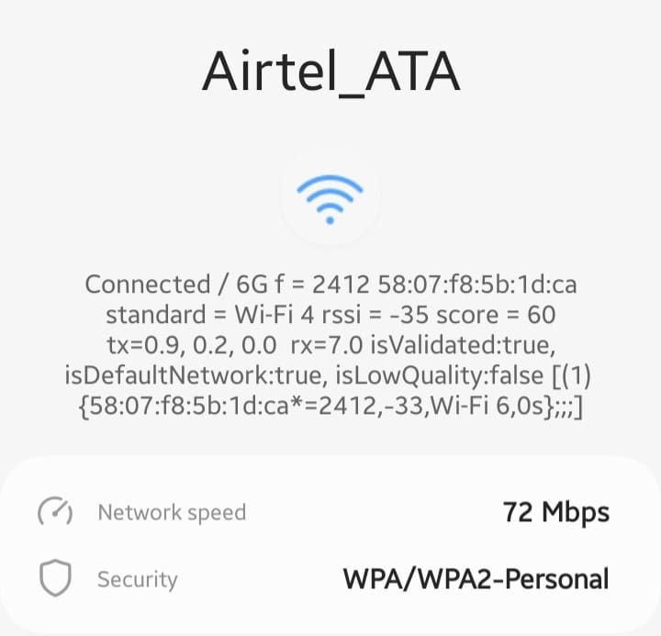

Wi-Fi Generation: Wi-Fi 4 (802.11n)

**3. What are BSS and ESS?**

* **Basic Service Set (BSS):** A single access point (AP) with associated devices in a small network.
* **Extended Service Set (ESS):** Multiple BSS units connected through a distribution system (DS) to extend coverage.

**4. Basic functionalities of a Wi-Fi Access Point**

A Wi-Fi Access Point (AP):

* Provides wireless connectivity to devices.
* Acts as a bridge between wired and wireless networks.
* Supports security features (WPA2, WPA3 encryption).
* Manages multiple device connections efficiently.
* Enables network monitoring and Quality of Service (QoS) control.

**5. Difference between Bridge Mode and Repeater Mode**

| **Feature** | **Bridge Mode** | **Repeater Mode** |
| --- | --- | --- |
| **Function** | Connects two separate networks. | Extends Wi-Fi range within the same network. |
| **IP Address** | Uses separate IP ranges. | Shares the same IP range as the main router. |
| **Use Case** | Links two LANs (e.g., office branches). | Boosts Wi-Fi signals in weak coverage areas. |

**6. Differences between 802.11a and 802.11b**

| **Feature** | **802.11a** | **802.11b** |
| --- | --- | --- |
| **Frequency** | 5 GHz | 2.4 GHz |
| **Speed** | Up to 54 Mbps | Up to 11 Mbps |
| **Interference** | Less interference | More interference due to common 2.4 GHz usage |
| **Range** | Shorter | Longer |
| **Adoption** | Used in enterprise networks | More common in early consumer devices |

**7.**

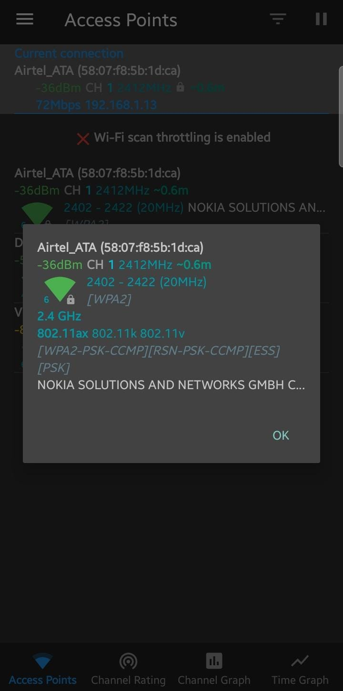

| **Property** | **2.4 GHz** | **5 GHz** |
| --- | --- | --- |
| **Speed** | Lower (e.g., 50-100 Mbps) | Higher (e.g., 300-800 Mbps) |
| **Range** | Longer (Better for distance) | Shorter (Weaker at long range) |
| **Interference** | More (crowded, overlaps with Bluetooth, microwaves) | Less interference |
| **Best Use Case** | Better for larger areas, walls, long-range | Best for high-speed close-range (streaming, gaming) |

**8. Difference between IEEE and WFA**

* **IEEE (Institute of Electrical and Electronics Engineers):**
  + Develops and standardizes networking protocols (e.g., IEEE 802.11 standards).
* **WFA (Wi-Fi Alliance):**
  + Ensures interoperability, security, and branding through certification programs.
  + Certifies devices for Wi-Fi branding (e.g., Wi-Fi 6 Certified).

**9. Wi-Fi Internet Connectivity Backhaul**

A backhaul is the connection between the main internet source (ISP) and your router/network. There are different types:

1. **Wired Backhaul (More stable, low latency)**

* Fiber Optic (FTTH - Fiber to the Home) → High-speed, low latency
* Ethernet (Cable Backhaul) → Reliable, used in mesh networks
* Coaxial Cable (Cable Internet) → Used in DOCSIS modems

2. **Wireless Backhaul (More flexible, but can be unstable)**

* Point-to-Point Microwave (Used by ISPs in remote areas)
* Satellite Backhaul (Used where fiber/cable is unavailable, high latency)
* Wi-Fi Mesh Backhaul (Routers communicate wirelessly)

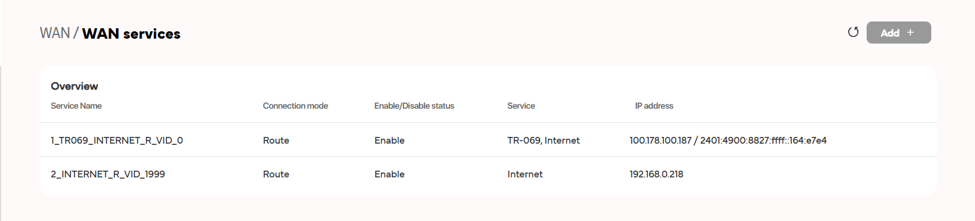

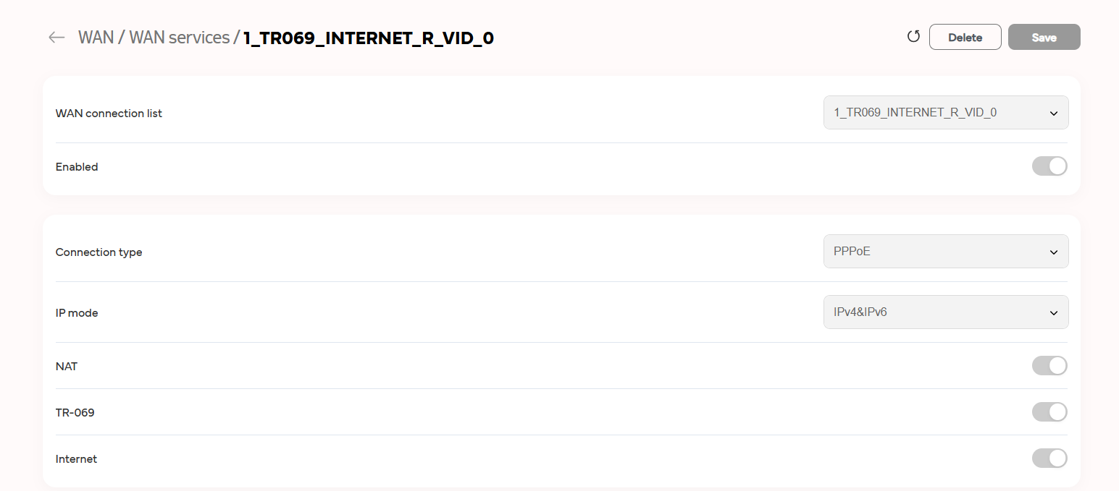

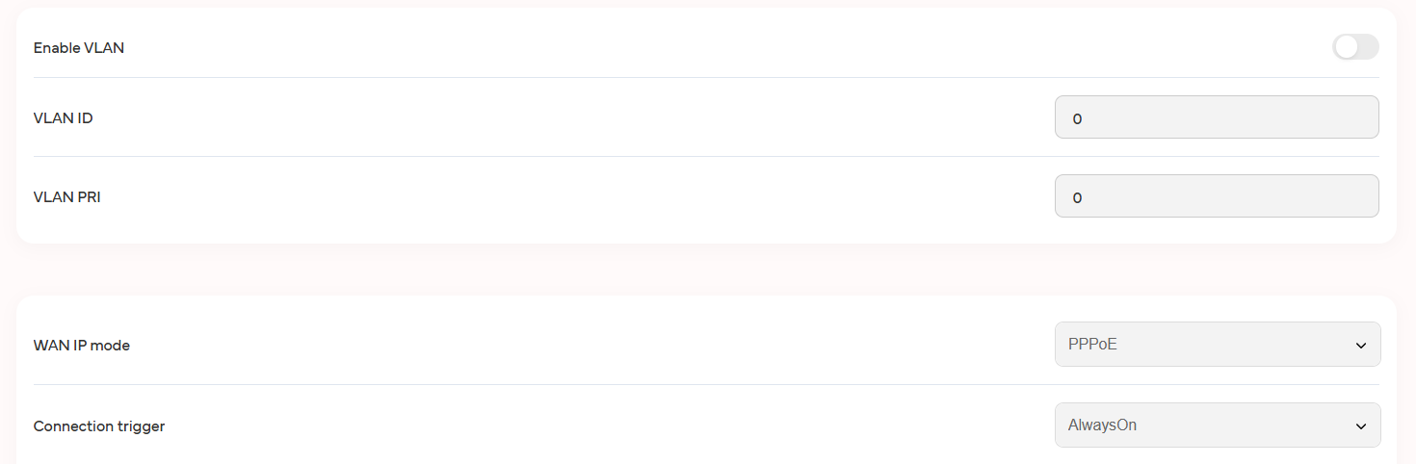

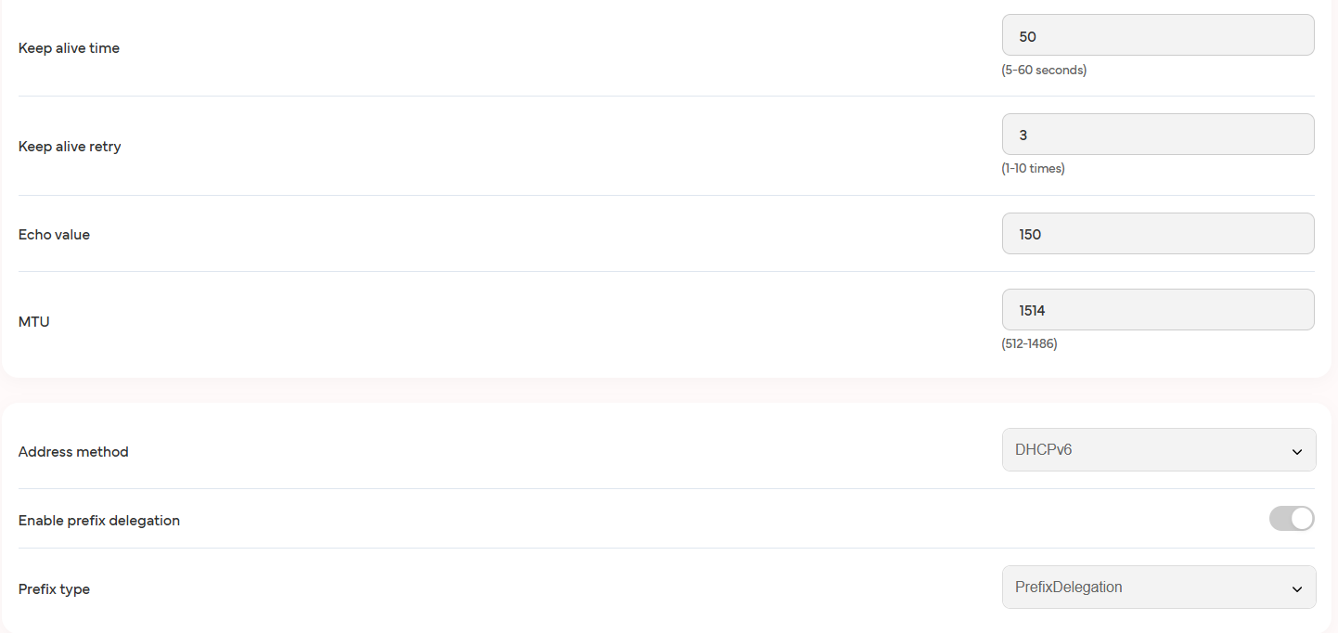

**10. Wi-Fi Topologies and Use Cases**

1. **Infrastructure Mode (BSS/ESS):**
   * Standard home, office, and public Wi-Fi networks.
2. **Ad-Hoc Mode (Peer-to-Peer):**
   * Direct device-to-device communication without an AP.
3. **Mesh Network:**
   * Multiple APs dynamically link for extended coverage (e.g., large campuses, smart cities).